
Easy Read Shadow Board Application Form

We need to receive your application by:

Friday 28th November 2025, 10am

Please send your completed application by email to:

yaag@dfnprojectsearch.org


Section 1
Personal Details

 | Your full name:

 | Your Date of Birth:

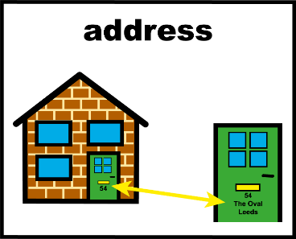 | Your Home Address:

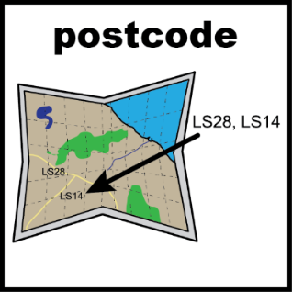 | Your Postcode:

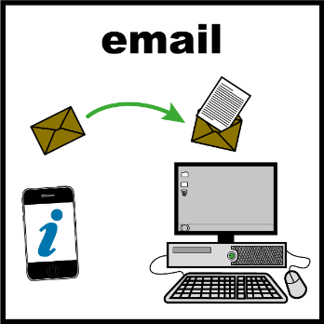 | Your email address:
Your phone number:
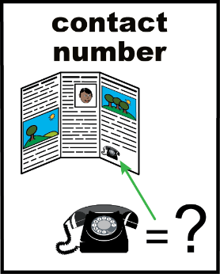

Section 2
Your Application

Please select which applies to you: | ☐ I am a current DFN Project SEARCH intern  ☐ I am a DFN Project SEARCH graduate

What is the name of your DFN Project SEARCH site?

Do you have access to a computer that you could use to join online meetings at home?   | ☐ Yes  ☐ No
Are you confident using Microsoft Teams?   | ☐ Yes  ☐ No

Are you comfortable talking to a group of 10-20 people online?   | ☐ Yes  ☐ No


Below is your opportunity to tell us about yourself and why you wish to join the Shadow Board. Please provide as much detail as possible.

Please tell us a bit about yourself and your DFN Project SEARCH experience.


Why do you wish to join the Shadow Board?


What skills and experience do you have that makes you suitable for this role?


Do you need any reasonable adjustments or support to complete this role?



