Join our Youth Advisory Group

2026-2027

This is an Easy Read version of the Youth Advisory Group Application Form.

 | This is an application form for the DFN Project SEARCH Youth Advisory Group.
 | Please let us know if you’d like this form in Welsh

 | You might also want to join the Shadow Board.  If so, please put a cross in this box ☐
 | Look at this website to learn more about the Shadow Board:  https://www.dfnprojectsearch.org/advocacy-and-engagement

 | Applications close on Friday 9th October 2026 at 5pm.
 | Send your finished form by email to: voice@dfnprojectsearch.org

Section 1
Section 1 asks for your Personal Details.

 | Write down your full name here:

 | Write down your date of birth here:

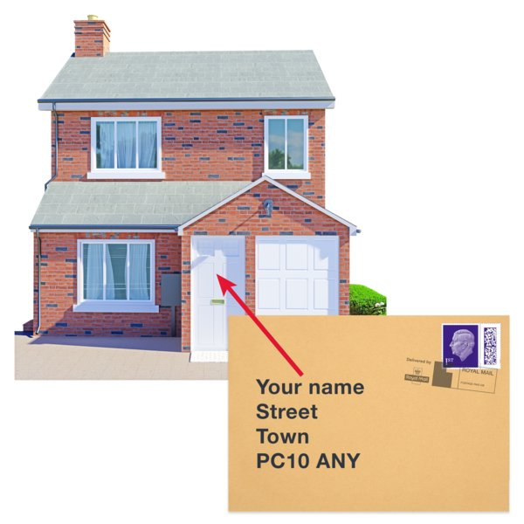 | Write down your home address here:

 | Write down your postcode here:

 | Write down your email address here:

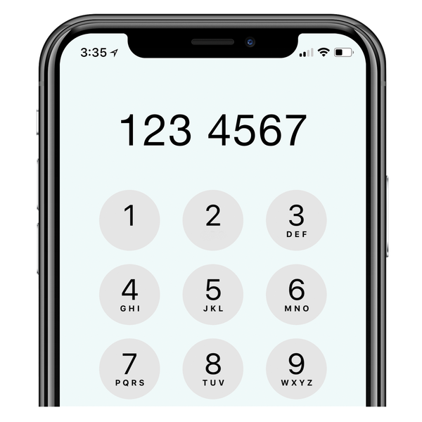 | Write down your phone number here:
 | Write down an emergency contact name and phone number here:
 | Say how your emergency contact is related to you:

Section 2
Section 2 is about your application.

 | Do you have a learning disability or autism?  ☐ Yes  ☐ No  ☐ Prefer not to say
 | Are you a DFN Project SEARCH intern?  ☐ Yes  ☐ No
 | What is the name of your DFN Project SEARCH site?

 | Can you use a computer for online meetings?  ☐ Yes  ☐ No
 | Are you confident using Microsoft Teams?  ☐ Yes  ☐ No
 | Are you comfortable talking in a group?  ☐ Yes  ☐ No
 | We have one or two away days per year. If needed, do you have someone to support with travel?  ☐ Yes  ☐ No  ☐ No travel support needed

Below is your chance to tell us about yourself and why you wish to join the Youth Advisory Group.

 | Tell us about yourself.
 | Why do you want to join the Youth Advisory Group?

 | What skills and experience do you have for this role?

 | Do you need any adjustments or support for this role?
315 words

